AI WEATHERWISE API
Mongoose Database, Schemas & Models
Naan Mudhalvan – Skill Wallet Group Project

Assigned Task: Install Mongoose, Create Database Connection, Create Schemas & Models

1. Task Description
The assigned backend task for the AI WeatherWise API is to integrate MongoDB using Mongoose, create a reliable database connection, and define schemas and models for storing application data.

2. Objectives
- Install the Mongoose package in the Node.js project.
- Create a reusable MongoDB database connection.
- Configure the connection securely using environment variables.
- Create Mongoose schemas to define the structure of application data.
- Create Mongoose models for database operations.

3. Step 1 – Install Mongoose
Open the terminal in the Node.js project directory and run:
npm install mongoose
Mongoose is an Object Data Modeling (ODM) library for MongoDB and Node.js. It provides schemas, models, validation, and convenient methods for interacting with MongoDB.

4. Step 2 – Configure Environment Variables
Create a .env file in the project root. Store the MongoDB connection string in an environment variable.
MONGO_URI=your_mongodb_connection_string
PORT=5000
JWT_SECRET=your_jwt_secret
GEMINI_API_KEY=your_gemini_api_key
The actual MongoDB connection string and API keys should be kept private and should not be committed to public source-control repositories.

5. Step 3 – Create Database Connection
Create a file such as config/db.js. This file contains the reusable function responsible for connecting the application to MongoDB.
const mongoose = require('mongoose');
const connectDB = async () => {
try {
await mongoose.connect(process.env.MONGO_URI);
console.log('MongoDB connected successfully');
} catch (error) {
console.error('MongoDB connection failed:', error.message);
process.exit(1);
}
};
module.exports = connectDB;

6. Explanation of Database Connection
mongoose: Imports the Mongoose library.
mongoose.connect(): Connects the Node.js application to the MongoDB database using the URI stored in MONGO_URI.
try/catch: Handles successful and failed database connection attempts.
process.exit(1): Stops the application when the database connection cannot be established.
module.exports: Makes the connection function available to the main application entry point.

7. Step 4 – Create Schemas
A schema defines the structure, data types, validation rules, and other properties of documents stored in a MongoDB collection. For the WeatherWise API, schemas can be created for users and weather records.

7.1 User Schema
const mongoose = require('mongoose');
const userSchema = new mongoose.Schema(
{
name: {
type: String,
required: true,
trim: true
},
email: {
type: String,
required: true,
unique: true,
lowercase: true
},
password: {
type: String,
required: true
}
},
{ timestamps: true }
);
module.exports = mongoose.model('User', userSchema);

7.2 Weather Schema
const mongoose = require('mongoose');
const weatherSchema = new mongoose.Schema(
{
city: {
type: String,
required: true,
trim: true
},
temperature: {
type: Number,
required: true
},
humidity: {
type: Number
},
condition: {
type: String
},
recordedAt: {
type: Date,
default: Date.now
}
},
{ timestamps: true }
);
module.exports = mongoose.model('Weather', weatherSchema);

8. Step 5 – Models
A Mongoose model is created from a schema and provides an interface for creating, reading, updating, and deleting documents in MongoDB. The User and Weather models allow the backend to work with user and weather data in a structured way.

9. Connecting the Database to index.js
The database connection function can be imported into the application's main entry point. The server should start only after a successful database connection.
const app = require('./app');
const connectDB = require('./config/db');
const PORT = process.env.PORT || 5000;
connectDB()
.then(() => {
app.listen(PORT, () => {
console.log(`Server running on port ${PORT}`);
});
})
.catch((error) => {
console.error('Database connection failed:', error.message);
process.exit(1);
});

10. Suggested Project Structure
weatherwise-api/
│
├── config/
│ └── db.js
├── models/
│ ├── User.js
│ └── Weather.js
├── routes/
├── controllers/
├── middleware/
├── app.js
├── index.js
├── .env
└── package.json

11. Expected Result
After installing Mongoose, configuring MONGO_URI, and starting the application, the terminal should display a successful MongoDB connection message followed by the Express server startup message.
MongoDB connected successfully
Server running on port 5000

12. Advantages
- Provides structured access to MongoDB through Mongoose.
- Makes database connection code reusable and maintainable.
- Schemas provide validation and consistent data structure.
- Models simplify CRUD operations.
- Environment variables help protect sensitive configuration values.
- The design can be extended easily as the WeatherWise project grows.

13. Project Screenshot
The following screenshot shows the assigned AI WeatherWise API task, including the requirements to install Mongoose, create the database connection, and create schemas and models.
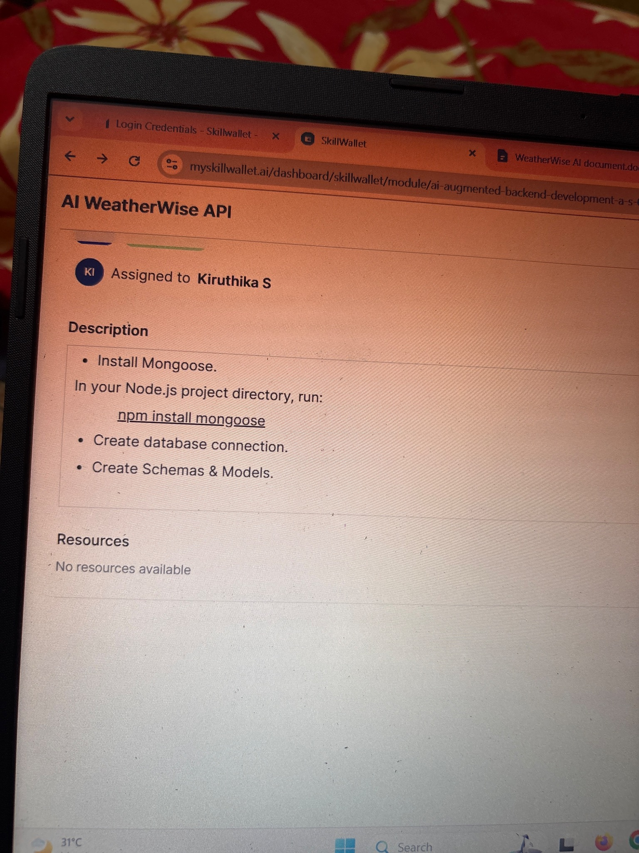

14. Conclusion
The Mongoose integration provides the AI WeatherWise API with a structured and maintainable way to communicate with MongoDB. By creating a reusable database connection and defining schemas and models, the backend can safely manage user and weather information and provide a strong foundation for the remaining API modules.

